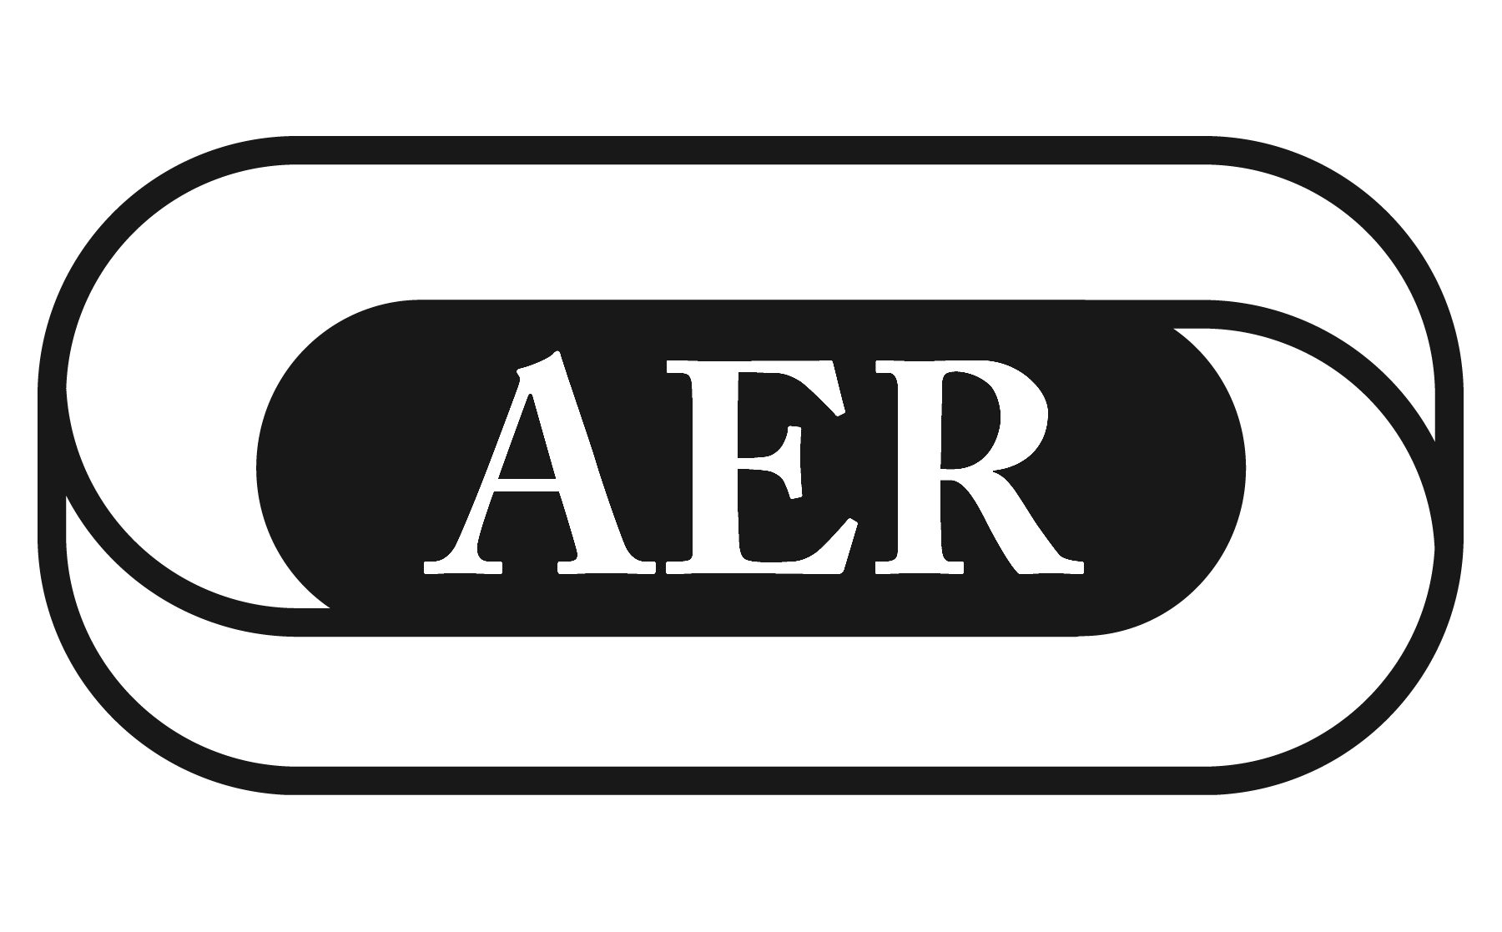
Association for Education and Rehabilitation
of the Blind and Visually Impaired

1703 N. Beauregard St., Suite 440 ▪ Alexandria, VA 22311-1744 ▪ (703) 671-4500 ▪
Fax (703) 671-6391 ▪ aer@aerbvi.org ▪ www.aerbvi.org

AER Organization Membership Application

Thank you for your interest in joining AER as a corporate member! We look forward to your active membership. To apply, complete this form and return it to AER with payment. A corporate membership is a non-voting membership and is non-transferable.

1. ORGANIZATION DATA (Please print) Application Date

Organization Name

Type of Organization (Select one)

__ Assistive Technology Company
__ Federal Agency
__ Private Non-Profit Agency
__ Public School System
__ School for the Blind
__ State/Provincial Agency
__ University/College
__ U.S. Veterans Administration
__ Other (More info
)

Primary Contact Name ( ____ Mr. ____ Ms. ____ Dr.)

Title

Mailing Address

City State/Province Zip + 4/Postal Code Country

Work Phone Fax Toll-Free

E-mail Web site

2. FEES

Organization Membership (fees in U.S. Dollars)
Annual Dues
❑ State School for the Blind $630
❑ State/Provincial/Federal Agency for the Blind $630
❑ All Other Organizations See Chart

All Other Organizations Dues Chart

Less than $700,000 Annual Operating Expenses $605
$700,000 - $1,500,000 Annual Operating Expenses $630
$1,500,001 - $3,000,000 Annual Operating Expenses $655
$3,000,001 - $5,000,000 Annual Operating Expenses $705
More than $5,000,000 Annual Operating Expenses $755

AER Organization Application – page 2

3. DIVISION MEMBERSHIP
AER has 16 Divisions that support and represent discipline-specific interests and are open to membership at an additional fee. AER Organization Members may add membership in up to three (3) divisions at no additional charge – indicate your free preferences below. Visit www.aerbvi.org for more information about Division missions and activities. If you wish to join more than three Divisions, check additional boxes below and add the fee(s) under Investment Calculation.

$10 – Administration
$10 – Rehabilitation Counseling and Employment
$10 – Multiple Disabilities & Deafblind
$10 – Psychosocial Services
$10 – Information & Technology
$10 – Low Vision Rehabilitation
$10 – Infant & Preschool
$10 – Orientation & Mobility
$10 – Education Curriculum
$10 – Vision Rehabilitation Therapy
$10 – Division on Aging
$10 – Itinerant Personnel
$15 – Personnel Preparation
$10 – International Services & Global Issues
$10 – Physical Activity and Recreation
$10 – Neurological Visual Impairment (provisional)

4. CALCULATE YOUR INVESTMENT
AER Membership Dues $
AER Chapter Membership $ Free
Three (3) Division Membership $ Free
Additional Division Memberships $
Total Amount Remitted $

5. PAYMENT INFORMATION
□ Enclosed is a check or money order made payable to AER for $
□ Please charge: VISA ___ MASTERCARD AMEX or _________DISCOVER
(Note: Credit card funds will be charged in U.S. dollars)

Card Number Exp. Date___________ CSC Code___________
Cardholder Name (please print)
Cardholder Address
Signature

If paying by check or money order: Mail to: AERBVI, 1703 N Beauregard St., Suite 440, Alexandria, VA 22311 USA.
If paying by credit card: Fax to 703-671-6391, mail to above address, or call 703-671-4500.

For more information about AER call 703-671-4500, visit the AER Web site at www.aerbvi.org, or send an e-mail to aer@aerbvi.org.

Mark your Calendars:

AER International Orientation & Mobility Conference 2017 – July 19-22, 2016, Pittsbugh, Pa. USA

