The AER Alabama Chapter Eye On Alabama Newsletter should be accessible to all magnification software and screen readers. Please contact us if you experience any difficulties or have any suggestions for improvements at 256-335-1080.

Alabama Institute for Deaf Blind News

Saying Farewell to Dr. Graham…Changing of the Guard at AIDB
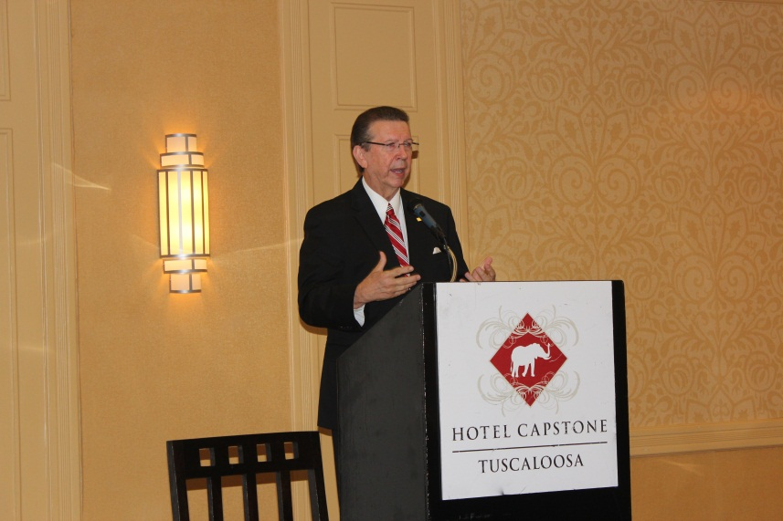

Pic: Dr. Terry Graham
Dr. Terry Graham has retired after serving 10 years as AIDB’s President. Before becoming AIDB president, Dr. Graham served in leadership positions for over two decades, including Principal of the Helen Keller School and Executive Director of the Office of Health, Evaluation, and Outreach. Dr. Graham will be remembered for his leadership in establishing the AIDB Regional Centers, promoting Early Intervention Services, forging a stronger partnership with ADRS, while growing services at AIDB during challenging economic times. When asked about retirement Dr. Graham stated, “I am looking forward to spending time with my grandkids. I know that I am leaving the institute in good hands with Dr. John Mascia.”
On January 1, 2013, Dr. John Mascia took the reigns as AIDB’s 17th president. He previously served as the Vice President of Adult Services under Dr. Terry Graham’s administration. He came to the institute in 2005 as the executive Director of E. H. Gentry. Dr. Mascia is well known for his community and consumer group support and leadership. His community work includes serving on the advisory committees for the Troy University Interpreter Training Program, State Mental Health Deaf Services Group, and the Department of Rehabilitation Services Older Blind Services, and the Board of Directors for the Talladega Red Door Kitchen. He has been the President of the Easter Seals Talladega County Chapter, Talladega Lions Club, and AER of Alabama. Dr. Mascia is currently an AER Board Member and Legislative Committee Chairman. Dr. Mascia is working with his Executive Board and the AIDB Board of Trustees to develop a vision for AIDB that builds on the foundation of his predecessor. “I am looking forward to this opportunity to serve”, said Dr. Mascia.
Submitted by Issac Beavers

New President’s Letter to You

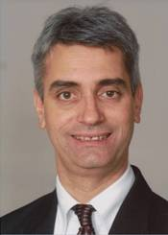

Pic: John Mascia
Heroes. They are the people who have earned special places in our hearts because of the great courage they demonstrate on the way to becoming role models for life. As professionals in the education and rehabilitation field we all have them – colleagues, consumers, family and friends.
I want to tell you about a couple of my heroes. As most of you know my early background is in audiology and speech pathology. I began my career as a clinical audiologist working in a hospital in New York, then went to work for the Helen Keller National Center for fifteen years in residential and field services before moving to Alabama eight years ago.
While I was in college at Hofstra University in New York, I had the opportunity to meet Dr. Robert Smithdas, the second deaf-blind American, after Helen Keller to receive a Bachelor’s degree and the first deaf-blind person to receive a Master’s Degree. I remember being awe-struck by how ordinary and productive Dr. Smithadas’ life was. While he is clearly a brilliant man, Bob has always been quick to point out that he would not have been able to live the life he has led… a great job, a wonderful and long marriage, a beautiful house and success playing the stock market, without the support, training and encouragement he has received from family, friends and service providers. He is one of my heroes. I have had two more heroes, my mother-in-law and my father-n- law.
My mother-in-law was born with muscular dystrophy and used a wheel chair. Mom went to college in the 50’s when women with disabilities didn’t usually get a college education. She became an English teacher and retired after almost 30 years of teaching in a junior high school. My father-in-law has no disabilities and was a dairy farmer which did not always produce a regular paycheck. But Mom and Dad relied on each other for support. He drove her to school every day and then picked her up every evening. Later in her career, when it was hard to hold a pen or type on a computer, she relied on Dad to get the information that was in her head, down on paper. They raised three successful children and became proud grandparents.
I learned from my heroes that none of us are completely independent and in fact, we are all inter-dependent. We all must rely on each other as we strive to fulfill our mission and achieve our dreams.
We all want the students and consumers we work with to experience the best that life has to offer - a job, a mortgage payment, the headache and blessing of raising children, if that is a goal. AER shares much with the Alabama Institute for Deaf and Blind (AIDB). We are both diverse and far-reaching in our mission and in the services we provide as a group of partnering agencies and organizations.
AER is a collection of the best professionals in the country and Alabama Institute for Deaf and Blind, established in 1858, is uniquely known as the world’s most comprehensive education and service program for children and adults of all ages with hearing and vision loss. We serve more than 21,000 individuals each year in all 67 counties of the state, operating five campuses in Talladega and a network of Regional Centers located in Birmingham, Dothan, Huntsville, Montgomery, Mobile, Talladega, Tuscaloosa and Tuscumbia.
As we move toward the future at AIDB we will foster an environment that embraces diversity and encourages all people, regardless of their disability, race or gender to achieve their goals and to make a difference in this world. And as my heroes have taught me- our success depends on us working together.
Helen Keller said, “it is my friends that have made the story of my life.” So it is for all of us – whether we are the teacher, consumer, administrator, professional, family member or friend. As the 17th president of Alabama Institute for Deaf and Blind I look forward to many years of working together as colleagues to discover new dreams and many new heroes!
Dr. John Mascia, President
Memorial - The Alabama AER Chapter has lost a great champion with the recent passing of “Jim” Highfield.

On January 24th, 2013, the Alabama Department of Rehabilitation Services, Business Enterprise Program lost a well-respected employee James W. “Jim” Highfield. Jim was highly thought of by his peers and the many blind vendors that he served. His professionalism and the advice and guidance that he provided assisted those he served and will be sorely missed. “Jim” as he was known to all of us was an employee of W.F. Woolworth for 20 years as sporting goods manager and employed with the Alabama Department of Rehabilitation Services for 25 years. Jim was an avid sportsman and member of the New Hope Baptist Church. Jim is survived by his wife, Samantha M. Highfield, son, Mike Highfield, daughter, Krista Watley (Eric), daughter, Kerri Wright, granddaughter, Brandi Graham (Bobby), granddaughter, Emma Wright, grandson, Kaden Watley, great-granddaughter, Gabbie Graham, sister, Janice Warren, sister, Joan Mclnnish (Billy), mother & father-in-law, Dot & Bill Wesson, and a host of nieces, nephews, and cousins.

Focus Story

VI Student: Julia Fleming

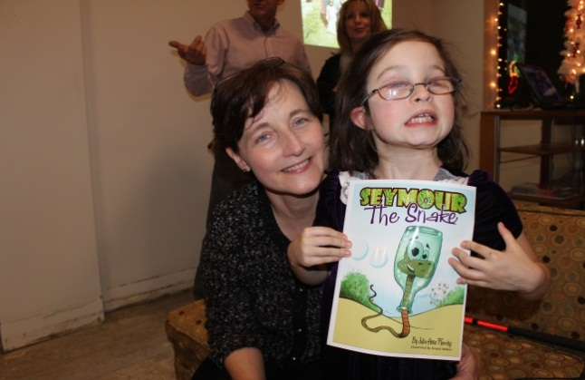

Pic: Julia with her mother, Dr. Pamela Quinn, at book signing in Arab

Julia Fleming, an eight-year-old from Arab, Alabama, is already a published author! Her book, Seymour the Snake, was conceived in her imagination when she was seven. Seymour is a snake who can’t see very well. He has many adventures, including crawling inside a bottle where he discovers that it helped him see better. Julia laughs when she says, “You know Seymour’s name is a blind joke…see more…get it?”
Julia is a proficient Braille user who has almost mastered all of second Braille. She reads and writes in Braille in her second grade classroom. Julia started Braille instruction as a three-year-old. Glen Tommie recently evaluated her for advanced technology and she is now learning to use refreshable Braille with an I Pad. Terri Watkins is Julia’s Vision Teacher, Susan Garmany assists her part-time in the classroom as a paraprofessional and Lisa Reburn is her COMS and vision consultant.
Julia won’t accept anything less than straight A’s and wants to be President of the United States when she grows up. She can quote the Preamble without a missed beat and she has an extremely engaging and energetic personality. When I asked Julia for permission to include her story in this newsletter, she said “Well, I guess it WILL make everyone more likely to vote for me for President!”
Submitted by Lisa Reburn

ADRS Client: For June Edition (please submit your focus stories)

Business Enterprise Program: For June Edition (please submit

your focus stories)

Alabama Association for Parents of Children with Visual Impairments AAPVI News
AAPVI sponsors four events each year: the Beeping Easter Egg Hunt, a Fishing Rodeo, an Adaptive Aquatics event and a Fall Conference in Orange Beach, AL. In addition, AAPVI collaborates with the UAB Center for Low Vision Rehabilitation to host a Weekend Family Camp Experience at Children’s Harbor on Lake Martin. AAPVI sponsored events include an educational, social and recreational component. Experts in the field of vision rehabilitation (including doctors, teachers, occupational therapists) and blind rehabilitation specialists provide the resources and information these children, young adults, and their families need in order to be able to compete with the sighted population in academics, in a chosen occupation, and in life. http://www.aapvi.org

Beeping Easter Egg Hunt
On Saturday, March 9, AAPVI hosted its annual Beeping Easter Egg Hunt at Triple S Farms in Wilsonville, AL. [Materials to manufacture the Beeping Easter Eggs are donated by the International Association of Bomb Technicians and Investigators. The beeping eggs are built by this group in coordination with agents in the local Bureau of Alcohol, Tobacco, Firearms & Explosives office and several other Alabama law enforcement agencies. The beeping eggs are shared with other organizations/states.] The children enjoyed hunting for beeping Easter eggs and sighted siblings and parents were blind folded so they could hunt the beeping eggs as well. Each beeping egg was traded for a plastic egg filled with candy goodies. The event was very well attended and laughter was everywhere!

Camping
The weekend of April 12 - 14, AAPVI will collaborate with Songs for Sight to host a Third Annual Children’s Harbor Weekend Family Camp Experience. Children’s Harbor is a fully accessible camp located on beautiful Lake Martin near Alexander City, AL. Last year, twenty-eight families and twenty-eight volunteers arrived on Friday evening. Once settled into assigned cabins, everyone enjoyed S’mores and hot dogs around the campfire. On Saturday, parents attended two breakout sessions. The children, ages 11 and older, participated in a Team Building activity at the Elements Course, while the younger children took turns walking and riding in red wagons to the Tree House, stopping along the way to participate in structured activities. After lunch, everyone enjoyed leisure time. Many opted to spend time in the water swimming, canoeing, or playing on the aqua jump while others chose to fish, play basketball, horseshoes or volleyball. Local boaters arrived in pontoon boats and ski boats to give everyone a ride. Saturday evening, after dinner, a Tacky Party was held with a Tacky King and Queen Contest. On Sunday after breakfast and a short chapel service, parents attended a third breakout session. The teens participated in a mentoring activity, while the children played goal ball, volleyball or jumped in the Bounce House. At noon, after a fun filled weekend, everyone said their goodbyes and departed for home. Pictures of the 2012 camp weekend can be found at http://www.smugmug.com/gallery/22463080_MVmG3N.
We are looking forward to another wildly successful camping weekend this year!

Fishing Rodeo
On Saturday, May 18, AAPVI will host its annual Fishing Rodeo at Sunshine Farms in Sterrett, AL. The children will have an opportunity to touch and learn about the farm and animals. In the early evening, everyone will gather on a beautiful, grass-lined, well-stocked lake with lots of hungry fish! North Shelby Baptist Church members volunteer their time and fishing poles to ensure all the children have an opportunity to catch a fish. Hot dogs and hamburgers will be grilled for a pot luck dinner. Pictures of the 2012 Fishing Rodeo can be found at http://www.smugmug.com/gallery/23068930_QSmhjq.
Join us for some serious fishing adventures!
Submitted by Chantal McManus

Alabama AER News

2012 State AER Conference!
Average of all evaluations by participants for the overall conference was a 4.51!
(5.0 being excellent and 4.0 being good)
Speakers included:
Tom Miller from the Blinded Veteran’s Association
Stephen Groff who spoke on Combat-related PTSD
Dr. Patti Fuhr from the SE Blind Rehab Center Services for Veterans
Susan Robinson representing Lakeshore & Operation Night Vision
Col. Gagliano from the Vision Center of Excellence
Of course there were excellent Exhibitor Presentations to keep us informed!
Fun Fun Fun included Lights Out Bowling, BINGO and a dance! 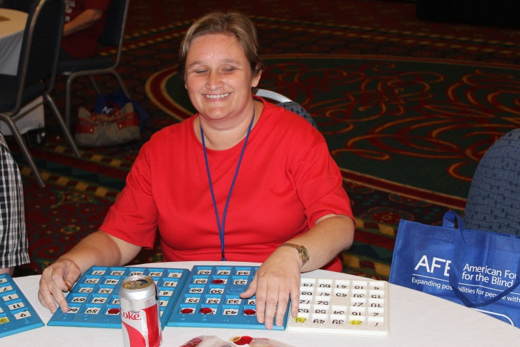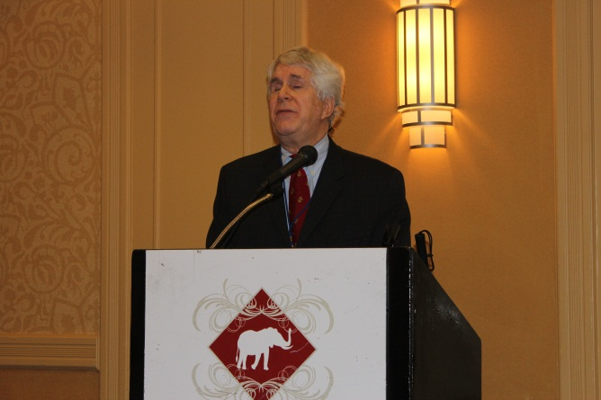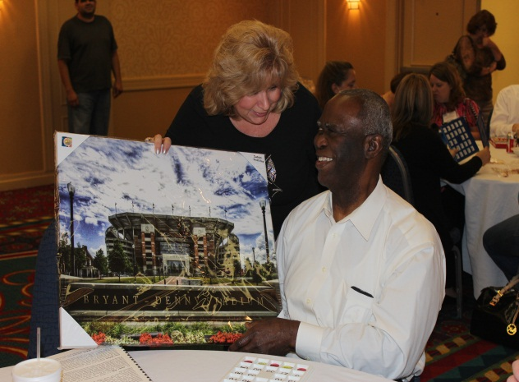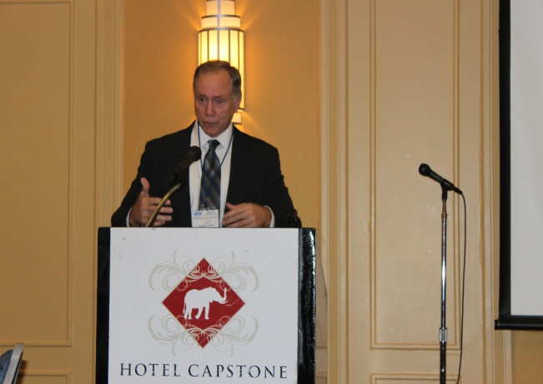
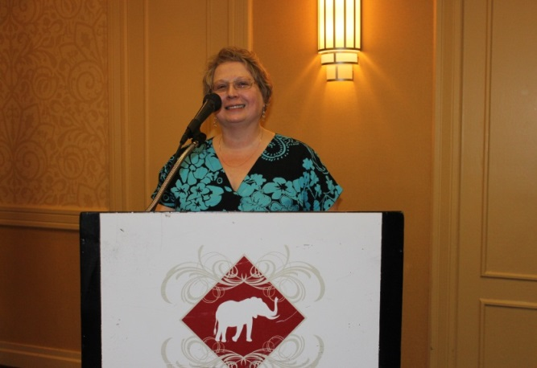
Upper Right: Tom Miller, Blinded Veterans Association
Middle Right: Dr. Stephen Groff,
Tuscaloosa VA Hospital
Left: Dr. Patti Fuhr, South East Blind Rehabilitation Center

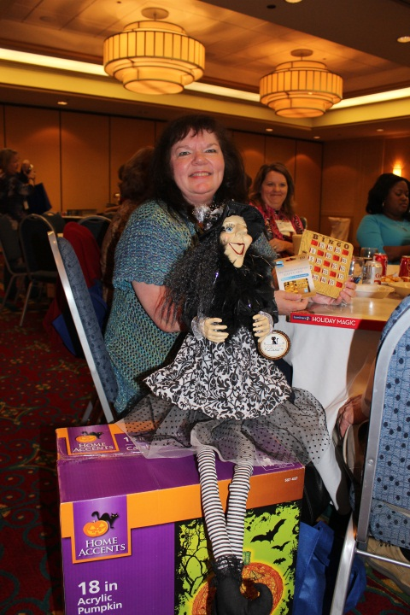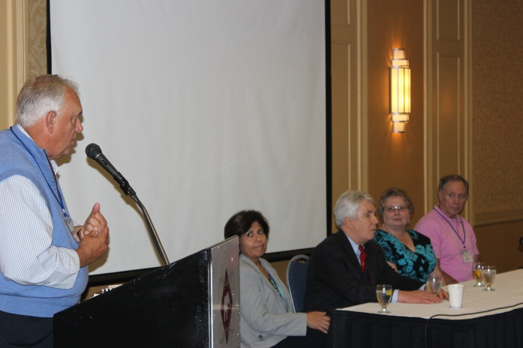

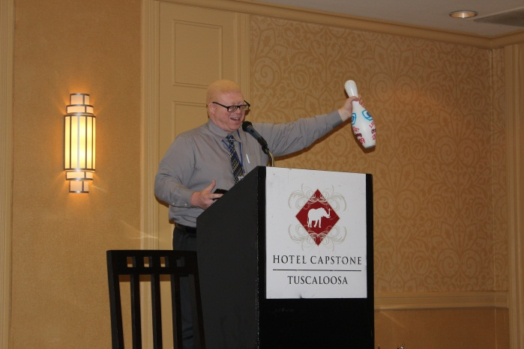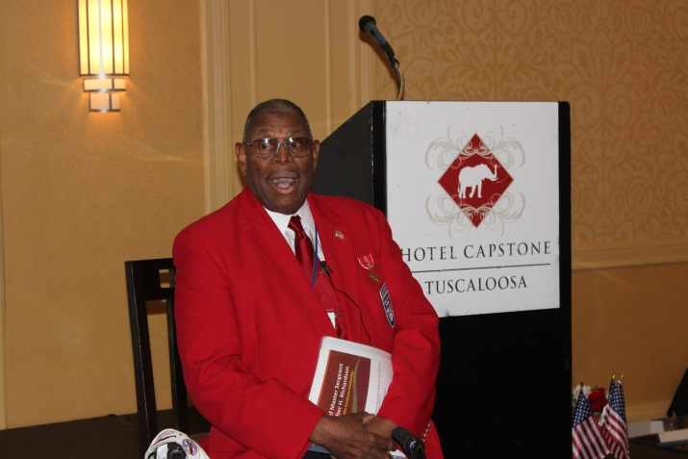
Lights Out Bowling Strikes Again!
Keynote Delivered by Tuskegee Airmen Walter Richardson
Lights Out Bowling Strikes Again!

Your New AL AER President! 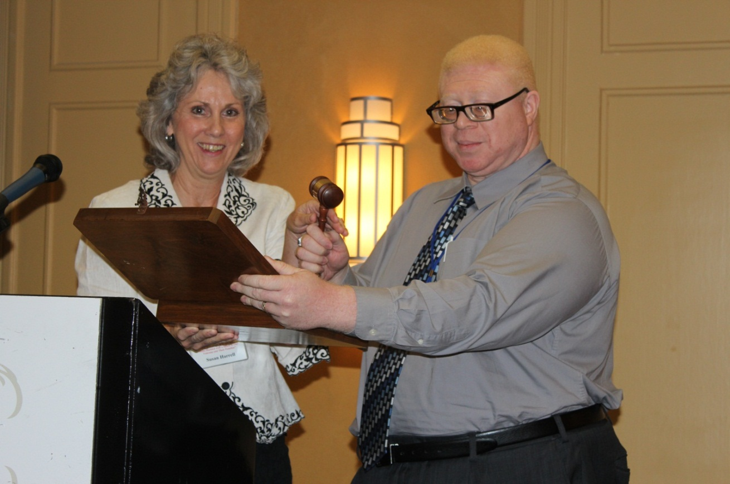

Pic: Susan passes the gavel to Isaac

30th Annual Conference, October 20 - 22, 2013
Guntersville State Park, Guntersville, Alabama

The Alabama Chapter of AER (Association for the Education and Rehabilitation of the Blind and Visually Impaired) announces its 30th Annual Conference to be held on October 20-22, 2013 at Guntersville State Park, located on the beautiful Tennessee River at 24 Campground Road, Guntersville, Alabama (256) 571-5455. The theme for the upcoming conference is “Blindness & Low Vision…..The Next 30 Years…Individuals, Families, and Communities”.
We encourage you to attend this educational conference which will include presentations from professionals, parents, and practitioners who will address issues and provide answers to many of the challenges faced by individuals who are blind or have low vision.
Preceding the conference on Sunday, October 20th, the Alabama Chapter Board of Directors and Conference Planning Committee will host the Billy Don Sims Golf Scramble, at the Eagle’s Nest Golf Course and the Bingo Blast will be held at 7:00 p.m. at the hotel. Don’t forget the Silent Auction whose proceeds go to support the Billy Don Sims Scholarship Fund.
For more information, please contact Caitlin Simpson, Conference Chair: (256) 522-0747,
caitlin.simpson@rehab.alabama.gov

Introducing Our New Board Members

Charlotte Lowery: 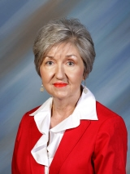
This is Charlotte’s 27th year at the Alabama School for the Blind (ASB). She started as the Independent Living teacher where she worked for three years. For the next 19 years, she was the director of the pre-vocational program. The 2012-13 school year will be her fifth as principal at ASB.
Charlotte says she is honored to be an Ex-officio trustee to the American Printing House for the Blind. She also served on the Educational Service Advisory Committee to the American Printing House for the Blind. Educating visually impaired students is Charlotte’s passion and she says that she treasures every day she gets to work at ASB.

Chantal McManus: 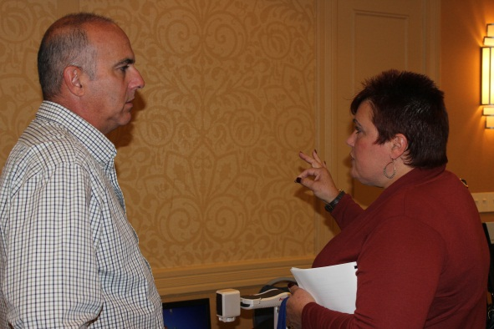
Chantal is an Itinerant Teacher. She provides direct services, consult services, assessment and evaluations in the area of Orientation & Mobility (O&M) and academic accessibility. As an O&M vendor for the state of Alabama, Chantal works with adults of all ages who are losing their vision or have lost their vision and are in need of training in the area of O&M.
Chantal is an active member of the National Federation of the Blind (NFB). She is also the President of the Alabama Chapter of the National Association for Parents of Children with Visual Impairments (AAPVI). Chantal volunteers for all events hosted by the UAB Center for Low Vision Rehabilitation, Songs for Sight, and Support group events. For the past 5 years Chantal has been a member of the Blind Advisory Committee (BAC) which meets quarterly in Montgomery. In 2012, Chantal received the Randy West award from the Governor’s Committee on Employment of People with Disabilities – Birmingham Area in Partnership with Birmingham Rehabilitative Professionals.

Scholarships Available!!

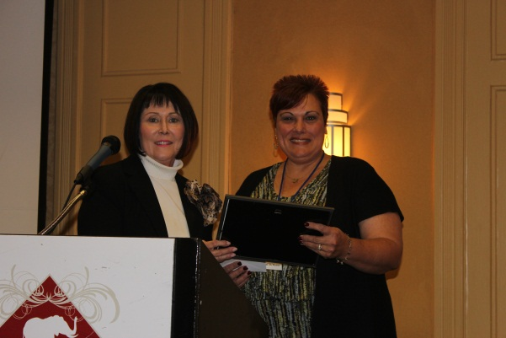

Pic: Julia Brock awards Chantal McManus scholarship for Hailey McManus
Congratulations Hailey!! Welcome to our field!!!

AL AER Offers Scholarship
Please share this information with interested students!
AER OFFERS SCHOLARSHIP
The Alabama Chapter of the Association for the Education and Rehabilitation of the Blind and Visually Impaired (AER) is offering an academic scholarship in the amount of $2000 to a resident of Alabama who is pursuing a degree in one of the following disciplines:
Rehabilitation Teaching
Orientation & Mobility
Teacher of the Visually Impaired
Rehabilitation Counseling
Related degree at the discretion of Scholarship Committee

The scholarship recipient will be announced at the 2013 AER Annual Training Conference to be conducted in October 2013. Applicants should apply in writing to the Scholarship Chairperson. The following information is needed in the letter of application:
- Name, Address, Hometown
- Degree Pursued
- Educational Institution Attending
- Statement of Purpose(one page describing your career plans including stated plans to work in the field of blindness)

Recipients must be enrolled in school for the 2013 school year
Applications must be postmarked no later than June 30, 2013, and should be mailed to:
Julie Brock, AER Scholarship Chairperson, 608 Brookside Drive, Northport, AL 35473

Upcoming Events:

Transition Events for Blind and Visually Impaired students

“The Wonder Games”

April 19, 2013 First United Methodist Church, Leeds, AL

For Birmingham, Talladega, Tuscaloosa, Huntsville and the Shoals

“The Wonder Games”

May 3, 2013 at the AIDB Regional Center for Mobile

AER International

Orientation and Mobility Conference 2013

December 11-14 in New Orleans, Louisiana

*See attached flyer

Please send your items for upcoming events of interest to the AL AER members to:
Lmoses99@una.edu or contact Lisa Reburn at 256-335-1080

"Exploring All Options"
AER International

Orientation & Mobility Conference 2013
Sponsored by the AER Orientation & Mobility Division

Dec. 11-14, 2013
New Orleans, Louisiana

New Orleans Hilton Riverside

If you were not among the 725 O&Mers that were in New Orleans December 2003 for the only O&M conference ever by AER, you probably heard about it and wished you were there!

Well, you won’t want to miss this one -- most of the same crew that brought you that conference (a little more seasoned but an excellent vintage!) are planning the most magnificently superb O&M conference you'll ever have the privilege of attending!

Membership Application
http://aerbvi.org/downloads/5/0/Individual%20Membership%20Application%20May%202011.pdf

